ASSIGNMENT NO:5 (ITC)” INTRODUCTION TO COMPUTING LAB” ROLL NO.0122 SEC:A3
NAME: Muhammad Zoraiz Sultan

Task 01– Positive Number? (if Statement) Estimated time: 10 minutes Asmall calculator receives an integer and reports whether the number is positive
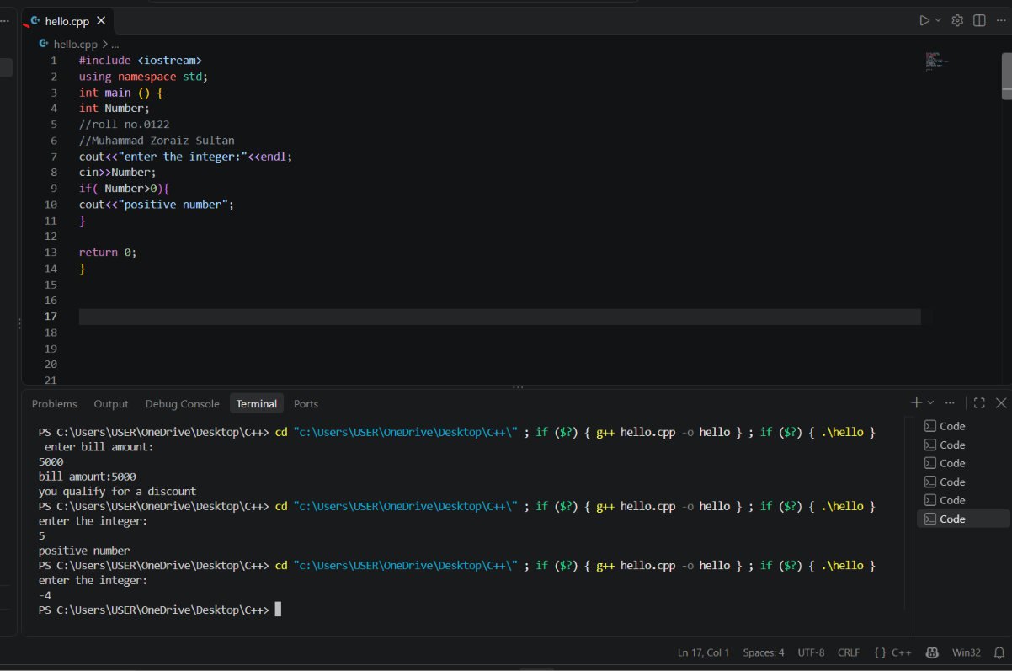

Task 02– Check the Discount (if Statement) Estimated time: 10 minutes Astore gives a discount message to customers whose bill is Rs. 5000 or more
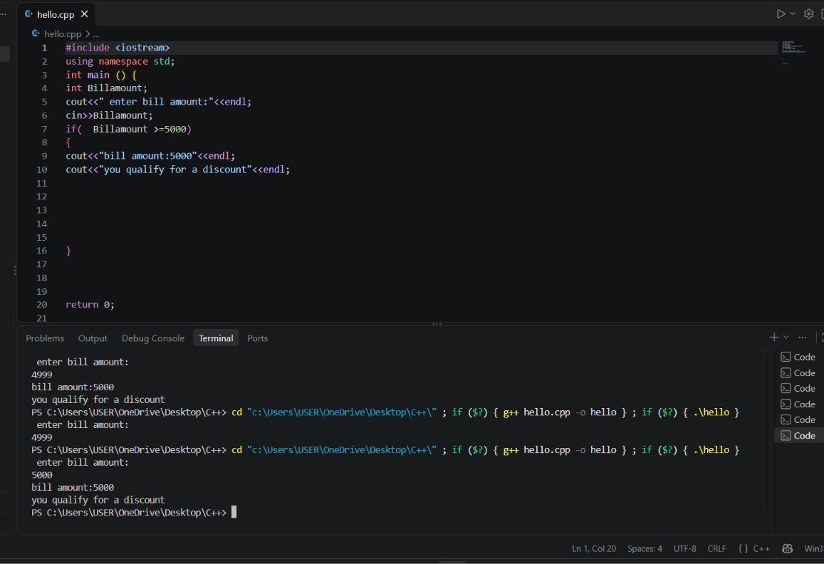
Task 03– Even or Odd(if-else Statement) Estimated time: 15 minutes Anumber-checking utility tells the user whether an integer is even or odd
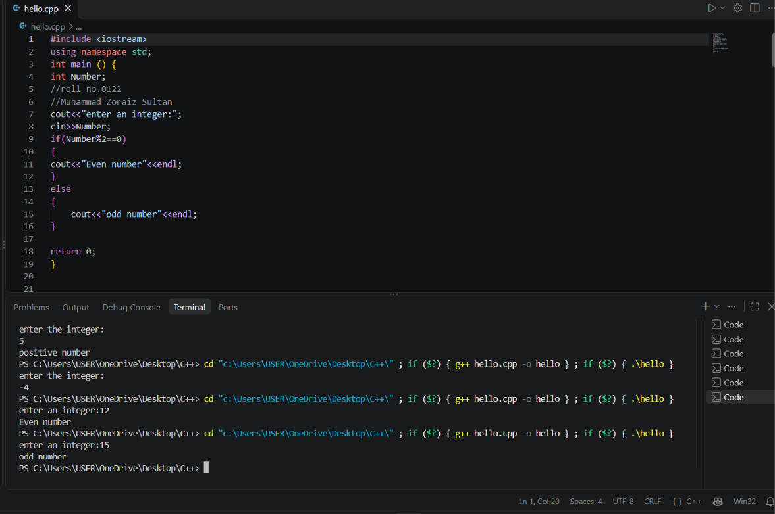
Task 04– Voting Eligibility (if-else Statement) Estimated time: 15 minutes Aregistration system checks whether a person is old enough to vote. The minimum age is 18
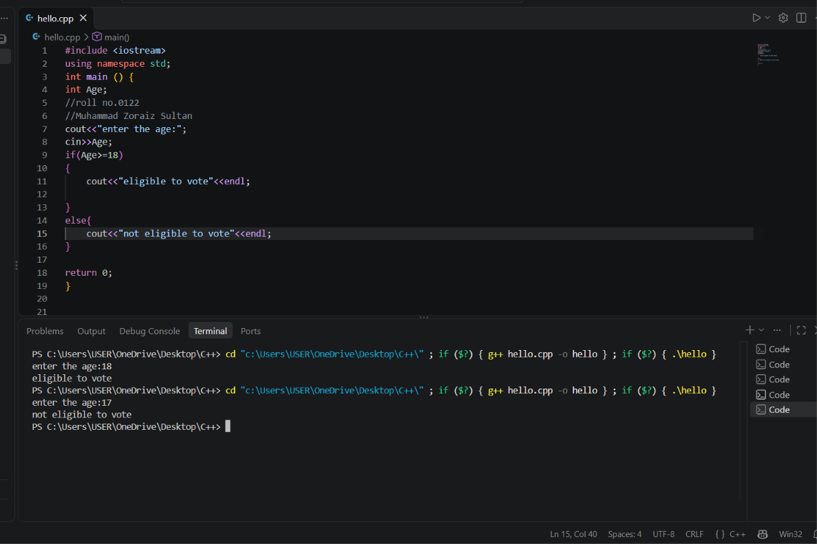
Task 05– Compare TwoNumbers(if-else Statement) Estimated time: 15 minutes Compare two integers and report whether the first number is greater than the second
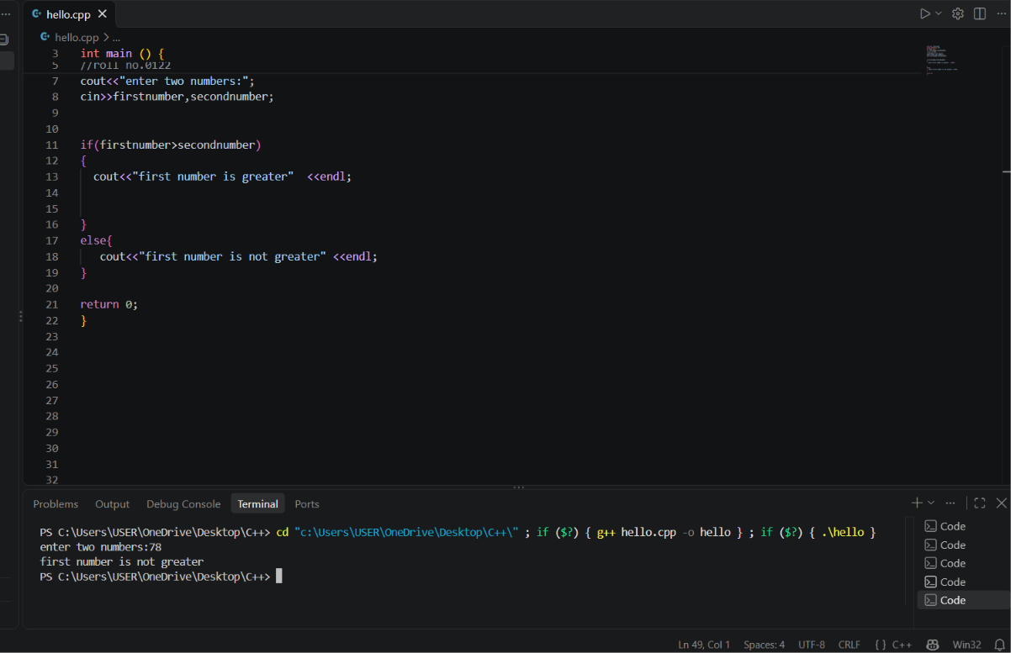
Task 06– Marks and Grade (if-else-if Statement) Estimated time: 20 minutes Ateacher assigns a grade according to a student's marks out of 100.
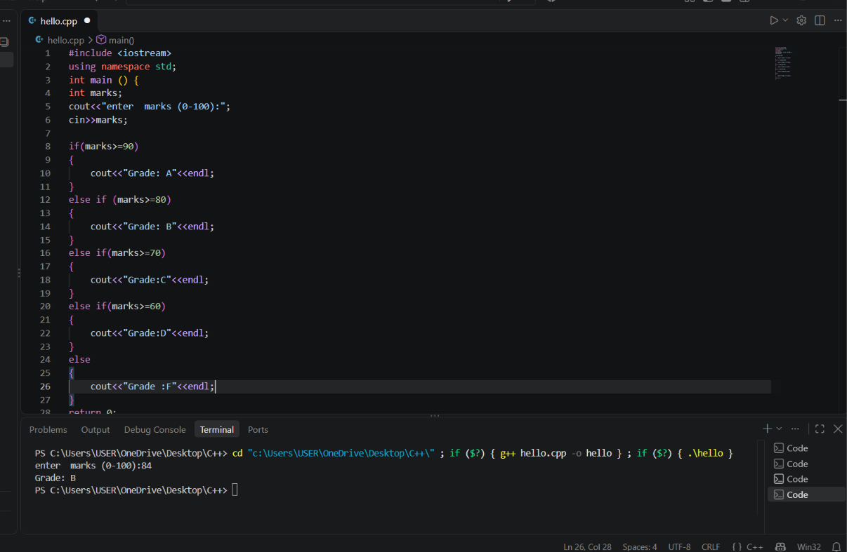
Task 07– Temperature Description (if-else-if Statement) Estimated time: 20 minutes Aweather application displays a description based on temperature in Celsius
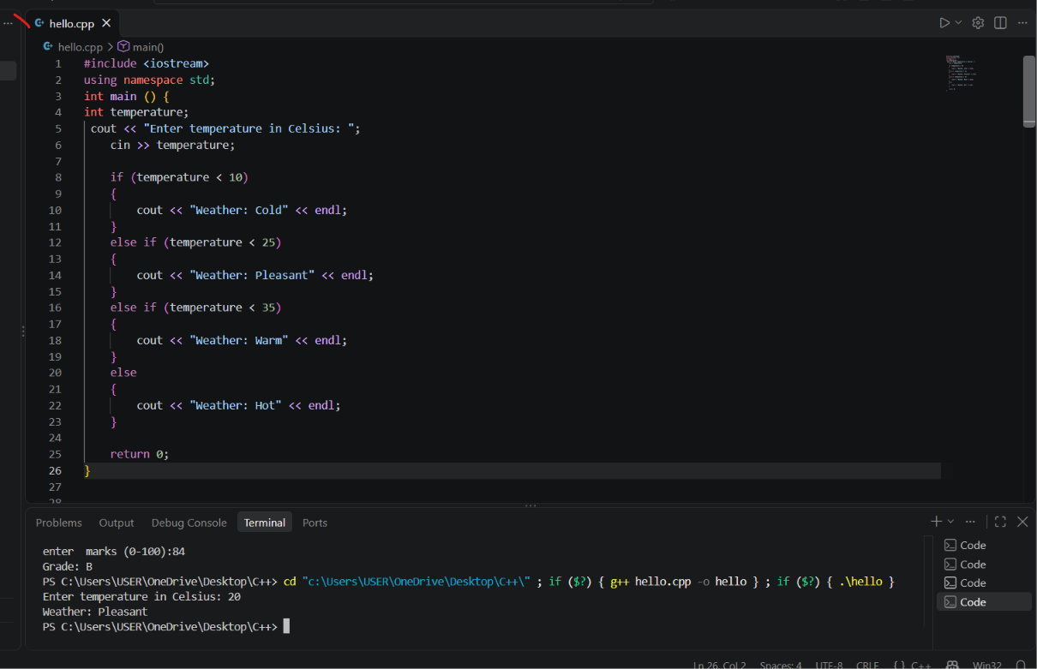
Task 08 : Debug the conditions:
The mistake is if (marks = 50). The single = assigns a value instead of comparing marks. We must use marks >= 50 to make all marks of 50 or more Pass.
#include using namespace std; int main() { int marks; cout << "Enter marks: "; cin >> marks; if (marks = 50) { cout << "Pass" << endl; } else { cout << "Fail" << endl; } return 0
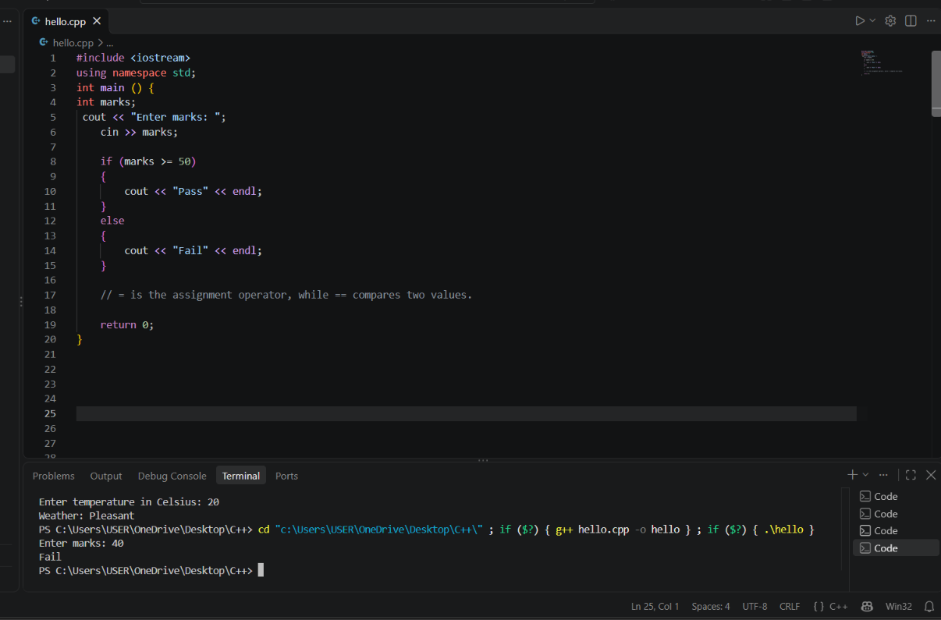
Task :09 Flowchart to Program :Electricity usage category
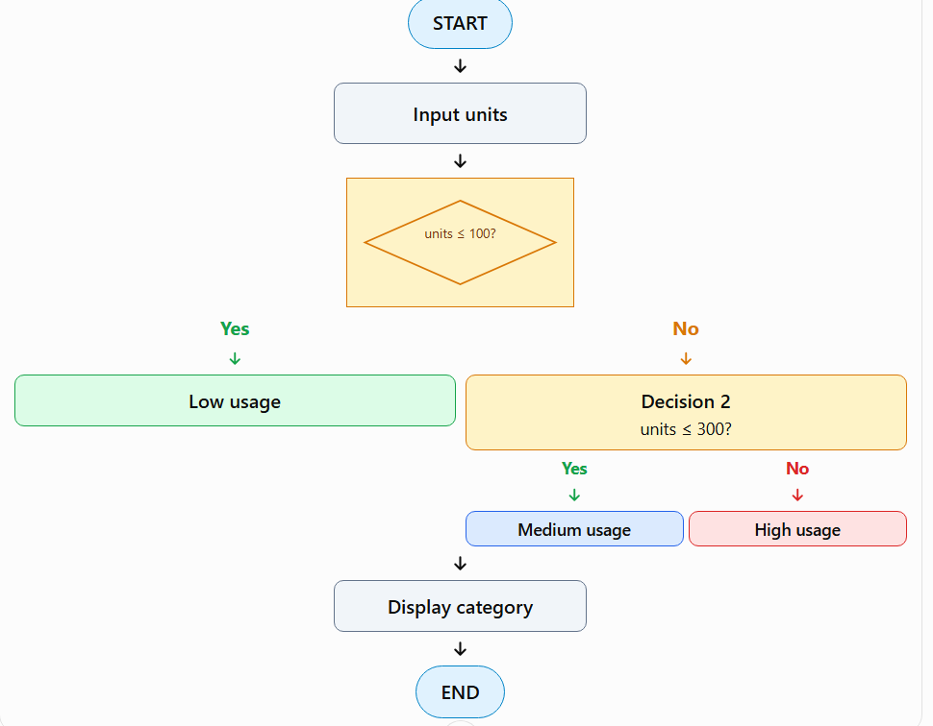
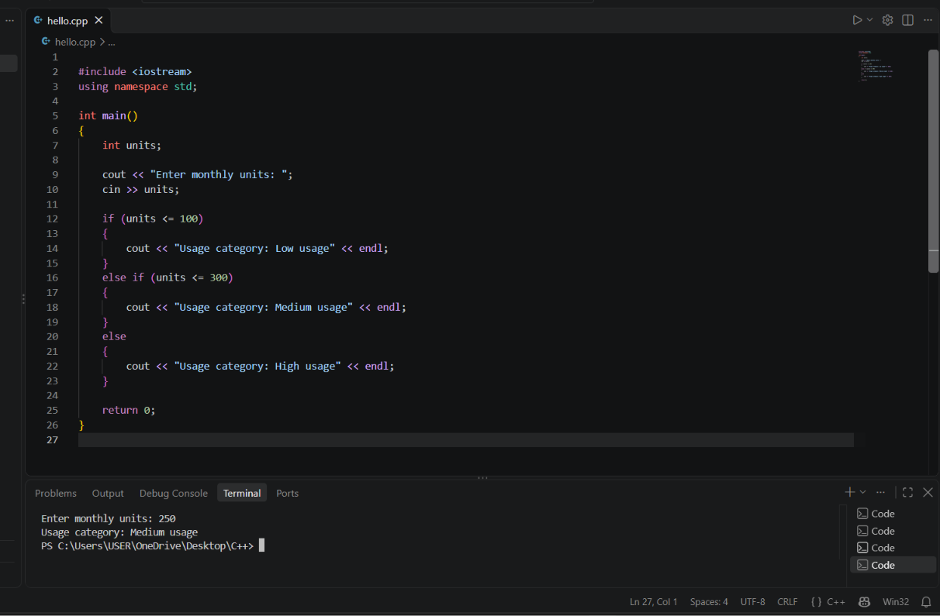
Task 10– Flowchart to Code: Scholarship Eligibility Estimated time: 20 minutes Adepartment awards a merit scholarship based on a student's marks. Use the flowchart logic to create a working program.
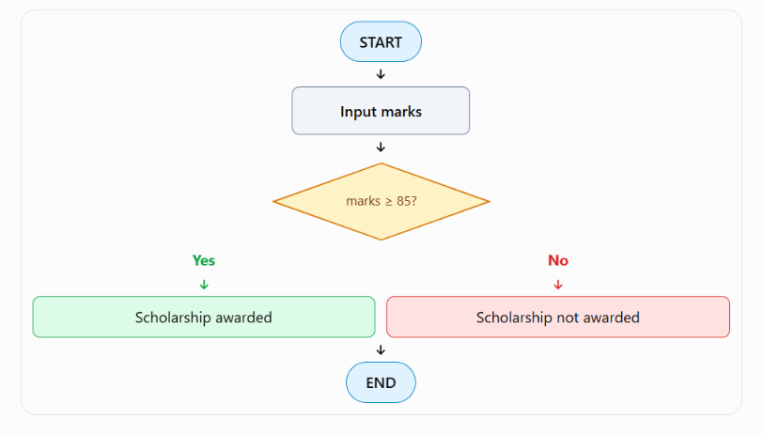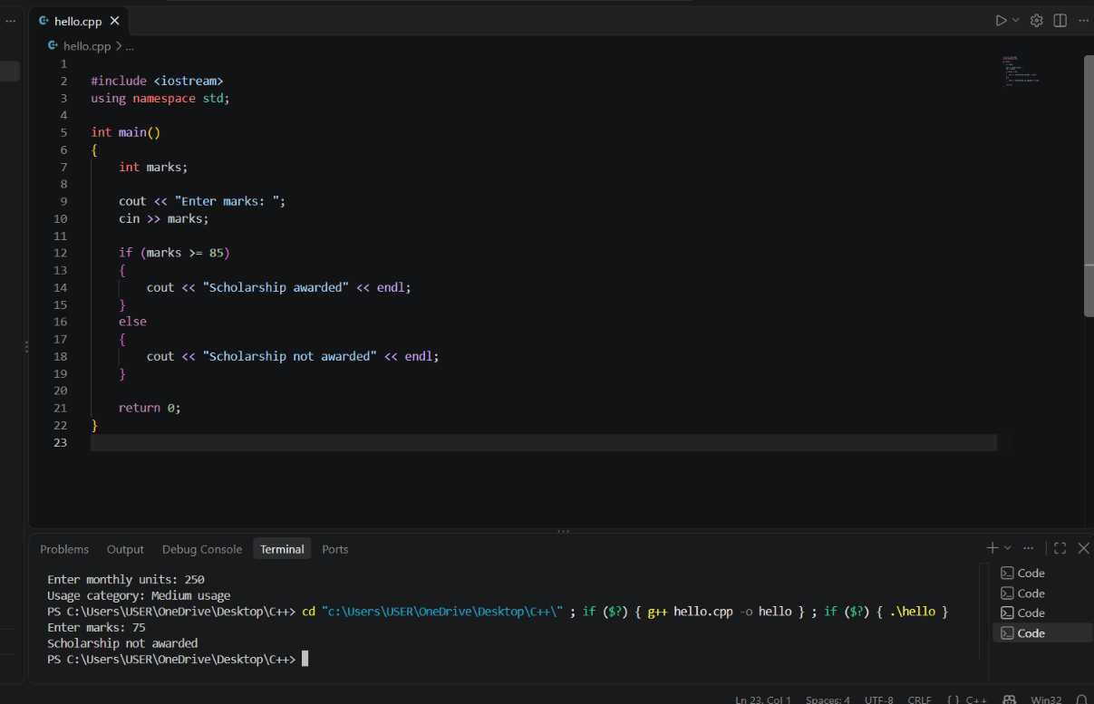
Task 11 :Museum ticket price:
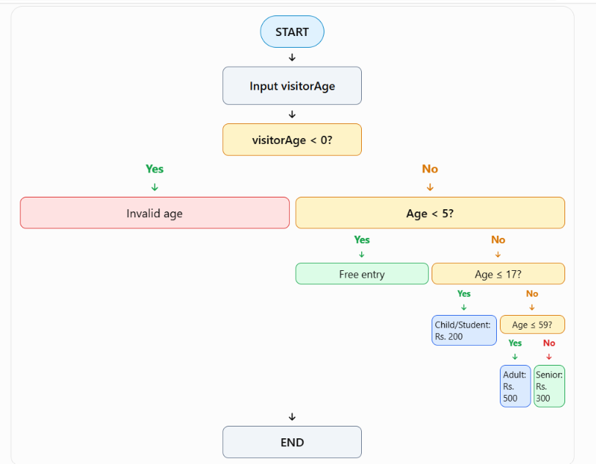
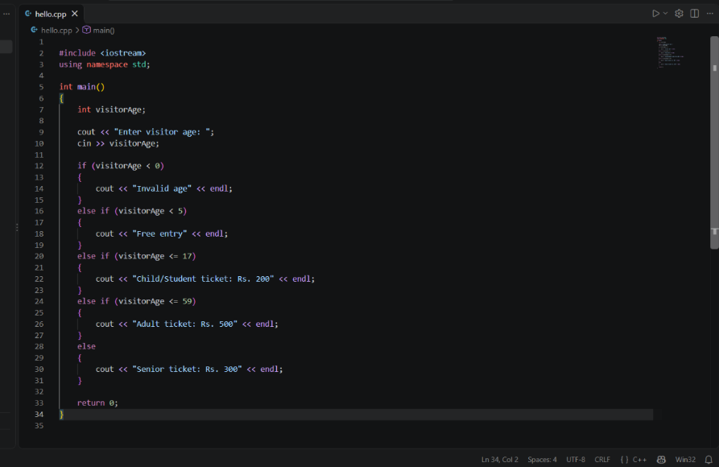
Output:


